**2. FREQUENCY RESPONSE OF CC AMPLIFIER**

**AIM:** To find the frequency response of a Common Collector Transistor Amplifier and to find the Bandwidth from the Response, Voltage gain, Input Resistance, output resistance.

**APPARATUS:**

|  |  |  |  |
| --- | --- | --- | --- |
| **S.No** | **Name** | **Range / Value** | **Quantity** |
| 1 | Dual Regulated D.C Power supply | 0–30 Volts | 1 |
| 2 | Transistor | BC-107 | 1 |
| 3 | Capacitors | 10f | 2 |
| 4 | Resistors | 100k, 10K | Each 1 |
| 5 | Resistors | 1K | 2 |
| 6 | Bread Board and connecting wires | - | 1 Set |
| 7 | Signal Generator | ( 0 – 1MHz) | 1 |
| 8 | Dual Trace CRO | 20MHz | 1 |

**CIRCUIT DIAGRAM:**

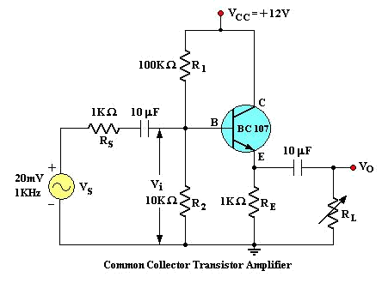

**MODEL GRAPH:**

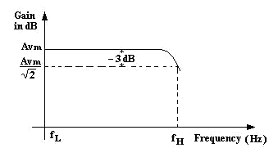

**PROCEDURE:**

1. Connect the circuit as per the Fig., Apply Vcc of 12 Volts DC.
2. Apply I/P Voltage of 20mV at 1KHz from the Signal Generator and observe the O/P on CRO.
3. Vary the frequency from 100 Hz to 1MHz in appropriate steps and note down the corresponding O/P Voltage Vo in a tabular form .
4. Calculate the Voltage Gain Av = Vo/Vs and note down in the tabular form.
5. Plot the frequency (f) Vs Gain (Av) on a semi-log Graph sheet
6. Draw a horizontal line at 0.707 times Av and note down the cut off points and the Bandwidth is given by B.W = f2 – f1.

**OBSERVATION:**

CIRCUIT DIAGRAM

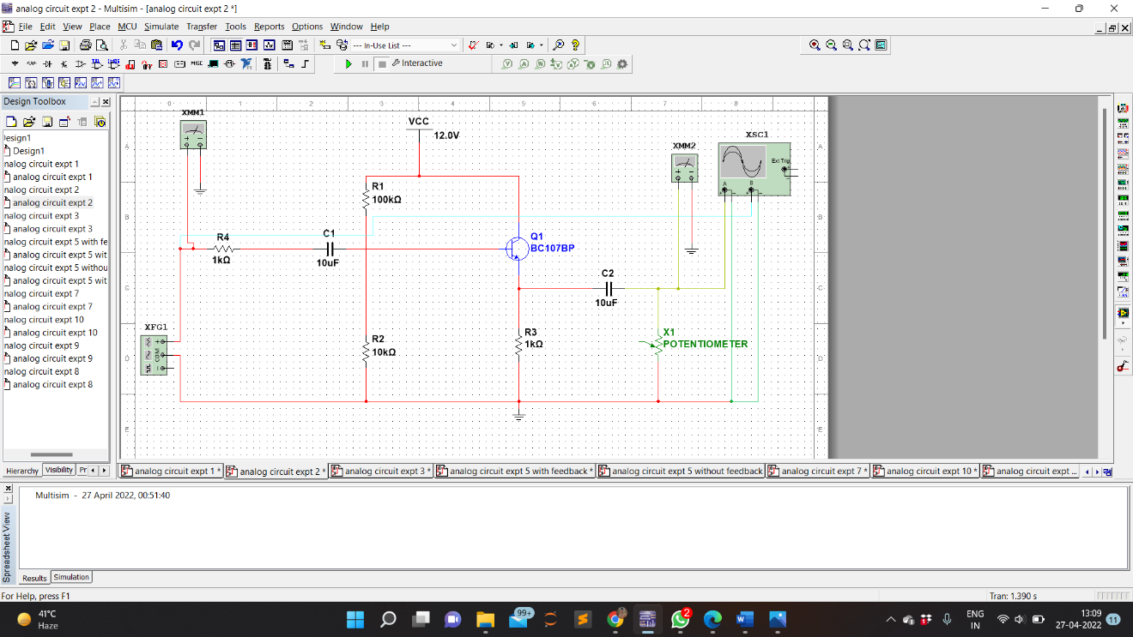

WAVEFORM

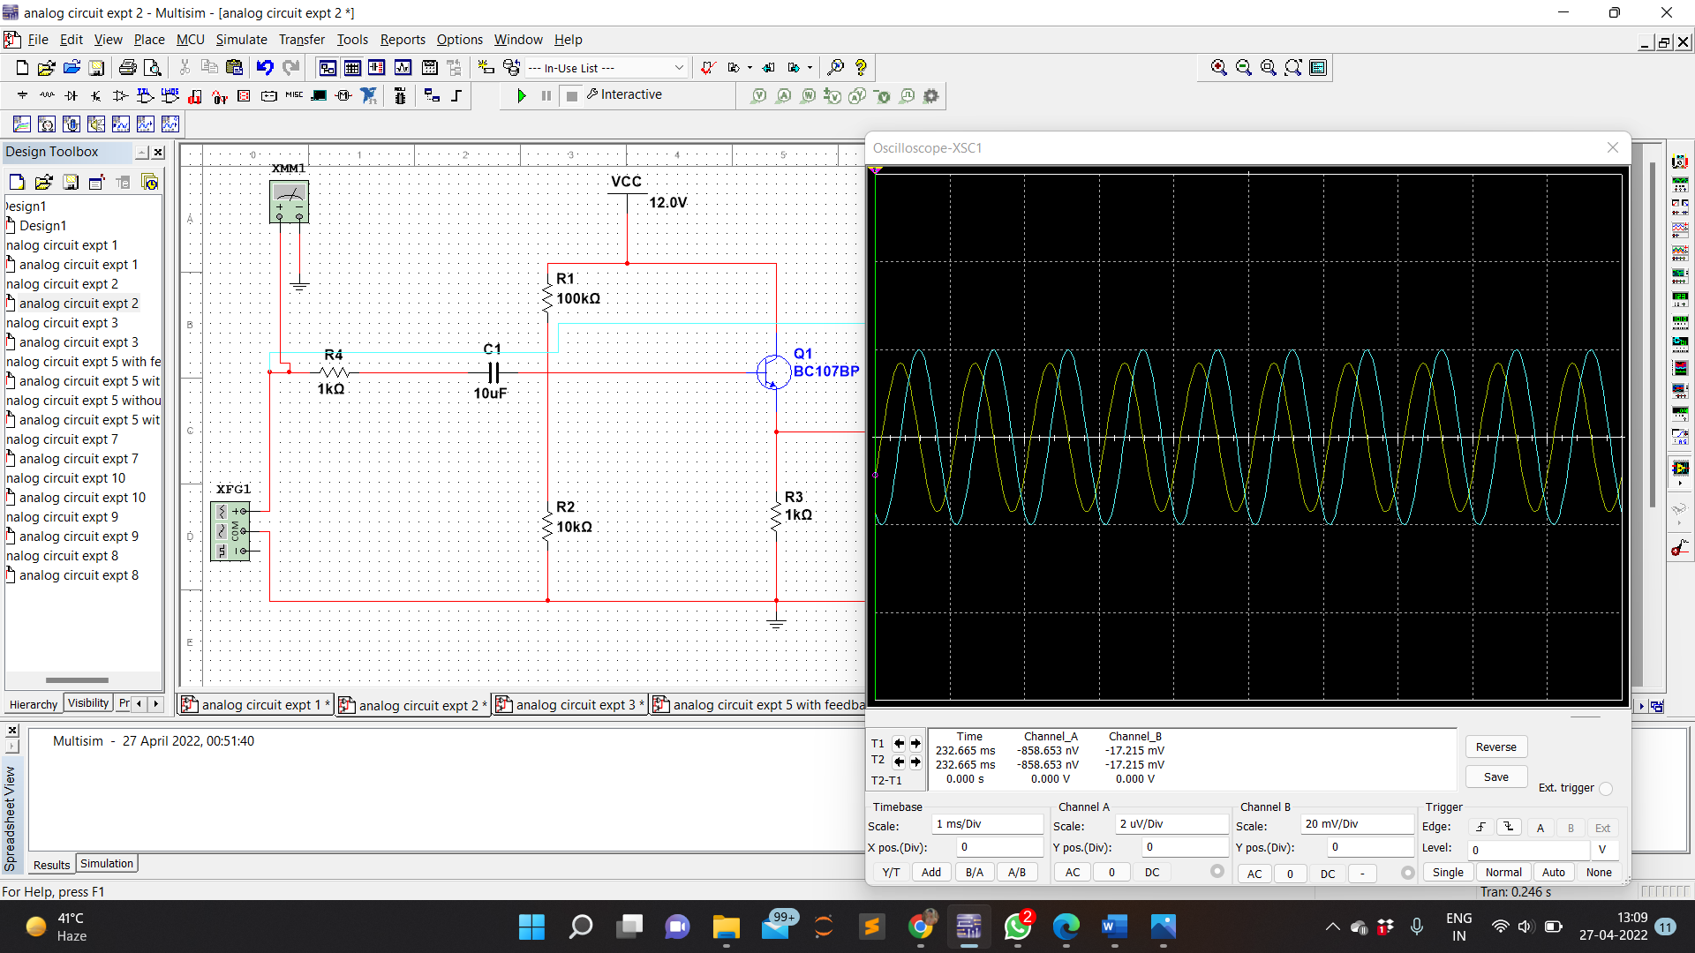OUTPUT VOLTAGE

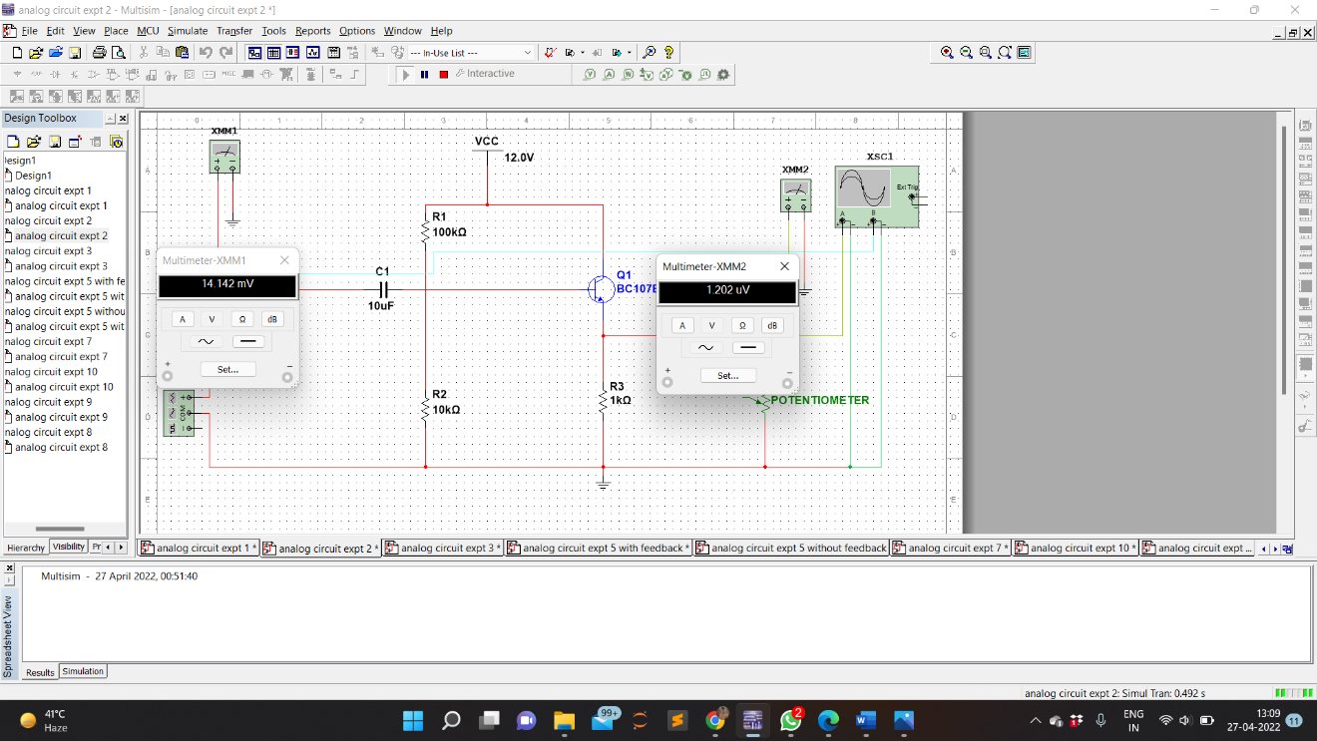

BANDWIDTH

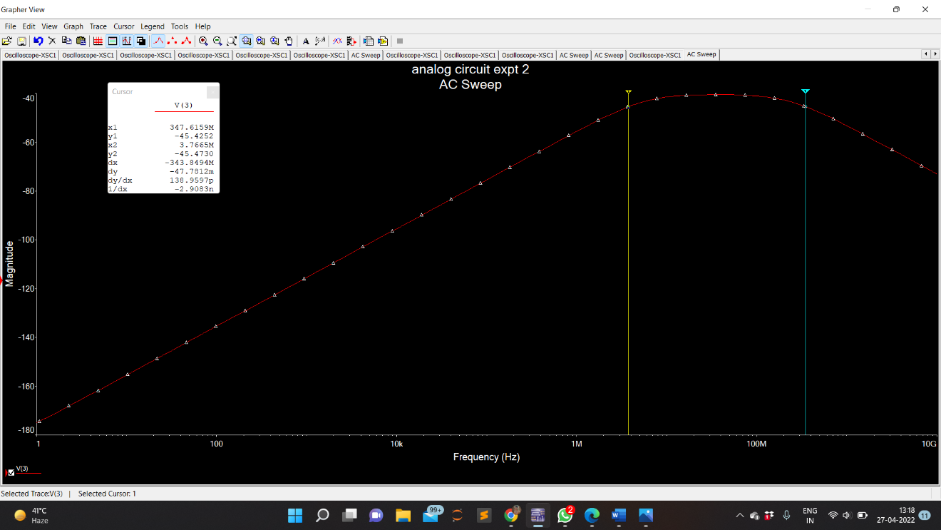

**CALCULATION:**

1. Input Frequency = 100 Hz

Output Voltage (Vo) = 120.202 nV

Input Voltage (Vin) = 14.412 mV

So , Voltage gain = Vo/Vin **=** 120.202nV/14.412mV

= 8.340u

Gain (dB) = 20 log Vo/Vin = 20 log (8.340)

= -101.4

1. Input Frequency = 1 kHz

Output Voltage (Vo) = 1.202 uV

Input Voltage (Vin) = 14.412 mV

So , Voltage gain = Vo/Vin **=** 1.202uV/14.412mV

= 0.0000834

Gain (dB) = 20 log Vo/Vin = 20 log (0.0000834)

= -81.56

1. Input Frequency = 1 MHz

Output Voltage (Vo) = 1.184 mV

Input Voltage (Vin) = 14.412 mV

So , Voltage gain = Vo/Vin **=** 1.184mV/14.412mV

= 0.0821

Gain (dB) = 20 log Vo/Vin = 20 log (0.0821)

= -21.7

Bandwidth = f**high –** f**low** = 347.6159 MHz – 3.7665 MHz = 343.8494 MHz

**TABULAR FORMS:**

I/P Voltage, Vs =14.412mV

|  |  |  |  |  |
| --- | --- | --- | --- | --- |
| **S.No** | **Frequency (Hz)** | **O/P Voltage, Vo (V)** | **Voltage Gain** | **Av in dB** |
|  |  |  | **Av =Vo/Vi** | **= 20 log (Av)** |
| 1 | 100 | 120.202 nV | 8.340 u | - 101.4 |
| 2 | 1K | 1.202 uV | 0.0000834 | -81.56 |
| 3 | 1M | 1.184 mV | 0.0821 | -21.7 |

**RESULT:**

Frequency response characteristics of Common collector amplifier is studied through the circuit designed and voltage gain and bandwidth has been studied and calculated.

**PRECAUTIONS:**

1. Check the wires for continuity before use.
2. Keep the power supply at Zero volts before Start
3. All the contacts must be intact